This is the evolution of:
- FS40 Pivot Bracket: this is the original project with 3 iterations.
- FS40+FS80+FS10 Pivot Bracket 1.0
So this is basically the 5th iteration of the original Pivot Bracket project.
Main goals
- Simplify the usage supporting only one camera family (FS40 – FS42). Trying to create a unified stand for CV60, FS10, FS20, FS40, FS80 proved to be cumbersome and the resulting bracket is difficult to use.
- Simplify the orientation and eventually use just 2 knob (one each side): one of the annoying task was the insertion of the lock knob in the right position. This because the exact angle was difficult to guess. Using a stepping system simplify this a lot because in many cases it is not necessary to lock the position, leaving the camera rotation free with a small torque.
- Make the camera adapter smaller, without the bulky pin and make it possible to store the camera in the original box with the adapter mounted on.

For the next iteration
→ Create a travel configuration for the camera using the 4 knobs
Add 2 holes to store also the T-Nuts (or maybe something with a more conformal shape for the T-Nuts
→ Review knobs to make them more comfortable to use
→ add a bump to the adapter so it can be locked in place also from inside the bracket and simplify positioning (same as with the rotation knob position)
→ Review the adapter to increase visibility
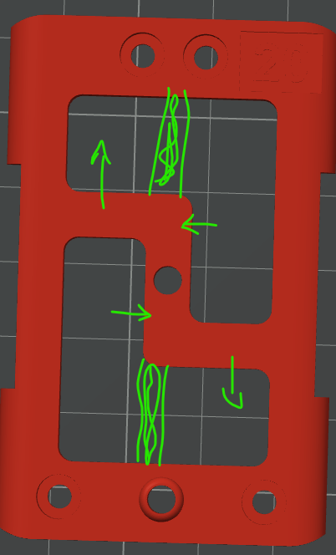

Insert a parking position for T-Nuts so we can have it but not interfere with the vertical standing position
→ Change the Knob screws to 3 mm
→ Make the knob larger to simplify usage (from 20 to 25 mm)

